# **LAB TASK 1**

**NAME:** ANUSHA SAAD

**ID:** 19K-0281

**Section:** H

**Course:** COAL

**Task 1:**

Done - Installed both Visual Studio 2019 and Irvine Library

**Task 2:**

Done - Configured as directed in the class and the manual.

**Task 3:**

Output Screen:

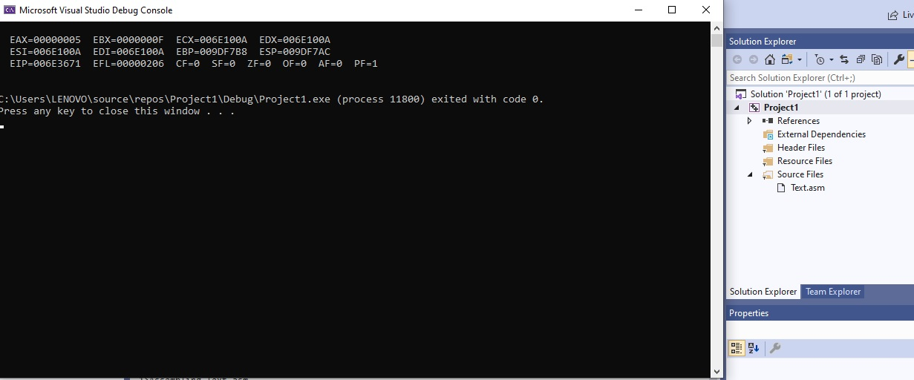

**Task 4:**

Output Screen:

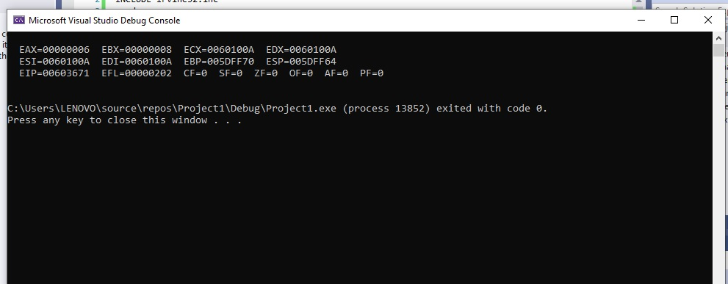

**Task 5:**

Step by step values of EAX and EBX:

* EAX = 012FFDF0 ; EBX = 010F3000
* EAX = 00000008 ; EBX = 010F3000
* EAX = 00000008 ; EBX = 0000000A
* EAX = 00000012 ; EBX = 0000000A
* EAX = 00000012 ; EBX = 0000000A

Output Screen:

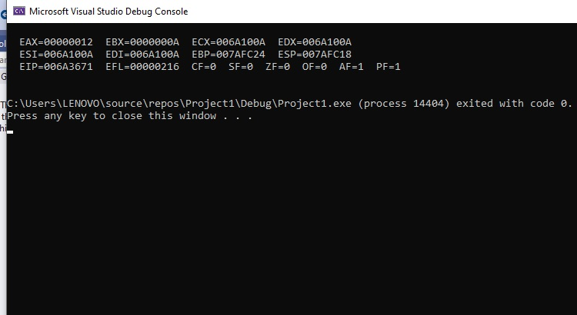

**Task 6:**

Step by step values of EAX and EBX

* EAX = 010FFEEC ; EBX = 00E2F000
* EAX = 0000000A ; EBX = 00E2F000
* EAX = 0000000A ; EBX = 0000000F
* EAX = 0000000A ; EBX = 00000005
* EAX = 0000000A ; EBX = 00000005

Output Screen:

